First quantum optimization technique:
1-QAOA: Quantum Approximate Optimization Algorithm
It is a hybrid quantum-classical algorithm used to find near-optimal solutions to complex combinatorial optimization problems

Q:How the algorithm works?
A: QAOA is a quantum optimization technique. Since it only works with binary (0/1) variables, continuous problems need to be discretized first — broken into levels, each represented by a binary variable
We assign costs to each variable/combination, forming a cost formula (the objective + constraints as penalties). This gets converted into QUBO (Quadratic Unconstrained Binary Optimization) format — a standardized binary math structure quantum tools can process.
Optimization problem → QUBO(QAOA lang) → Ising Hamiltonian → QAOA circuit
The QUBO is then translated into a Hamiltonian — a physics formula representing total energy, mathematically converted into an equivalent Ising Hamiltonian, which represents the optimization problem as the energy of a quantum system. Lower energy corresponds to lower objective cost.
The quantum circuit runs multiple iterations — guessing a combination, measuring its energy, and a classical optimizer adjusting the circuit's parameters repeating until it converges on the lowest-energy (= lowest-cost) combination it can find."
Or
The quantum circuit runs multiple iterations by preparing a superposition of possible solutions, evaluating them through the cost and mixer layers, measuring a candidate solution, and letting the classical optimizer adjust the circuit parameters until a low-cost solution is found.

Problem I tried to make with qiskit simulator :
Scenario: Modern smart homes must continuously decide how to distribute energy efficiently throughout the day. In this scenario, the day is divided into three time slots—Morning, Afternoon, and Evening where the energy management system must determine whether to use battery power, draw electricity from the grid, or reduce energy consumption by turning off the air conditioner. Since battery energy is limited, decisions made in one time slot directly affect the available energy in subsequent time slots. Therefore, the challenge is to find the optimal combination of decisions that minimizes overall operating cost while considering battery wear, electricity cost, and carbon emissions, without violating the constraints.
Our objective function minimizes a weighted combination of grid electricity cost, a carbon emissions penalty, and battery wear cost, while rewarding AC shutoff as a saving across three time slots, subject to some constraints ensuring exactly one battery level is active per slot and that power availability is guaranteed

We try to have best combiniation between those:
Summation (For each time slot ):
0.27xgrid -0.20 AC + 0.0125 battery_low + + 0.025 x battery_mid + 0.0375 x battery_high
How each number we got it :
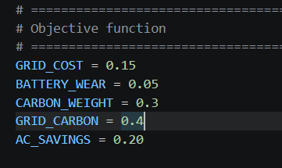
Each variable has its own weight , calculated in advance from real-world factors like price and carbon weight these coefficients are what get combined into the overall linear cost equation, which then gets converted into QUBO form.
So for example grid to calculate the cost coffecient it will be :
So 0.15 + 0.3 x 0.4=0.27
So we will repeat and for each of them until we want to minimize =
Total Cost = morningcost + afternooncost + nightcost
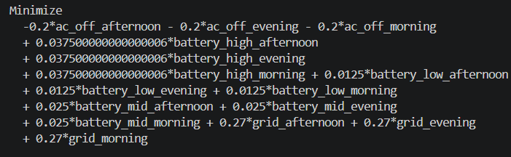
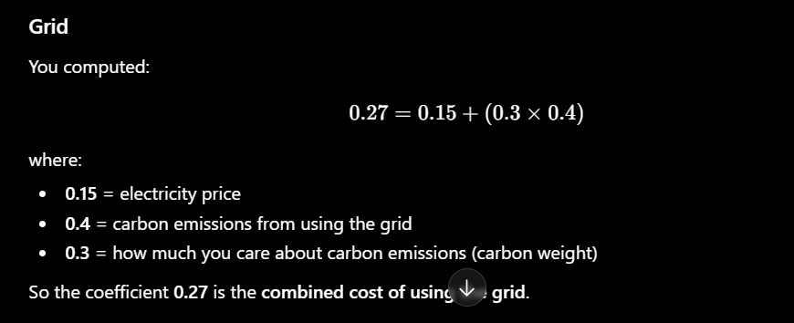
the coefficients are calculated from real-world factors (electricity price, battery wear, carbon emissions, etc.) and represent the contribution of each decision to the total objective cost. The optimizer then tries to find the combination of decisions that produces the lowest total cost while satisfying all the constraints.

And also our constraints is :
- at most one battery level each time slot
- must have power grid or battery
- total budget battery ( not used due to out of memory error I had , but I will try to fix it )
in first constraint we force to pick zero or one battery level

(else ) second constraint it can be 1 thing either a Grid or battery

Third constraint it checks that total of the battery doesn’t exceed 4 which is 100% as the optimizer can pick 75% in each slot
Notice in the third constraint : Battery units are just a whole-number mapping of the real battery percentages, used specifically because this constraint is an inequality (<=). Qiskit converts inequality constraints into equality constraints using a slack variable — a helper variable that absorbs the difference between the actual value and the limit. Calculating the valid range for that slack variable requires whole-number steps, not decimals, so any inequality constraint with decimal coefficients fails. Since our limit (4) represents 100% battery capacity, we scaled the battery levels into whole units (1, 2, 3) instead of decimal fractions (0.25, 0.50, 0.75) specifically for this constraint. As each one unit is 25% so 4 x 25 = 100%

QAOA (and several optimization converters in Qiskit) are designed to work with problems expressed as equalities. The slack variable is simply a mathematical trick that converts an inequality into an equivalent equality without changing the set of valid solutions.

Code: C:\Users\ibrah\OneDrive\Desktop\quantum-energy
Some of imports :
StatevectorSampler: runs your circuit on a local simulator
MinimumEigenOptimizer: the wrapper that connects QAOA to the problem and actually runs the solve

COBYLA : classic optimizer that tunes QAOA circuit angle between iterations
Maxitar : Run the full circuit, adjust gamma/beta, and try again — but stop after at most 20 attempts
Before explaining what COBYLA what is doing in simulator we will explain how the
Circuit contain two layers :
1-cost
2- mixer
Before the cost layer begins, QAOA applies a Hadamard gate to every qubit. This creates a superposition, meaning each qubit simultaneously represents both 0 and 1 as possibilities. As a result, the entire quantum register represents many possible combinations at once instead of a single classical solution. The cost and mixer layers then manipulate this superposition to increase the probability of measuring low-cost solutions.
1-cost :
It takes the cost formula applies it directly to the qubits as a set of gates (hamilition) it slightly shifts each qubit's state based on how that qubit relates to cost. If a qubit represents something expensive (like "use grid"), the cost layer nudges that qubit slightly toward "less likely to end up as 1."If a qubit represents something cheap/good (like turn off AC), it nudges it toward "more likely to end up as 1

How is that happening?
Let ‘s say that our equation:
It takes 15 * (grid) which is one qubit and it takes its coff and represents it as rotation gate applied to that qubit
Rotation gate it is like spinning dial with arrow ,A rotation gate literally spins that arrow by some amount. it's a physical operation that shifts the qubit's leaning between 0 and 1.
The amount of spin is directly determined by the cost formula's number for that variable:

- Term with coefficient 15 (grid, expensive) → applies a rotation gate that spins the qubit's arrow toward "less likely to measure as 1" (avoid it)
- Term with coefficient -0.20 (AC off, saves money) → applies a rotation gate that spins the qubit's arrow toward "more likely to measure as 1" (favor it)
If two variables is multiplied by each other and has cost on both it will not take one ofThem like before it will become two qubit gate a gate that links those two specific qubits' spins together, rather than spinning just one qubit alone (my current cost formula is all single variable terms, so I am using one-qubit)
So here COBYLA here has gamma value beside the coff of the cost function this gamma it tuned every round of spin it as it after full circuit runs it will adjust gamma and re run the full again (gamma controls the cost layer's push strength)
The coefficient helps determine the rotation applied in the cost layer together with γ (gamma).

2- mixer layer:
If we only apply the cost layer it will get stuck on one solution and never explore another options as it will take first good options and never see another solution ( it will be greedy)
The mixer job : spread the qubits' possibilities back out a bit, letting them explore other combinations they haven't tried yet, instead of collapsing too early into one guess.

It also have parameter that COBYLA try to tune which is BETA so bigger beta = more exploration , smaller beta=smaller exploration

Repeating this pair (that's your reps=2 two rounds of cost+mixer) gradually steers the qubits toward good combinations without prematurely locking onto the first cheap-looking one.
So how it is look like having 2 reps :
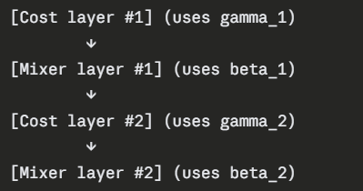
My anaology it is like neural network layers:
Here is a comparison of the neural and QAOA
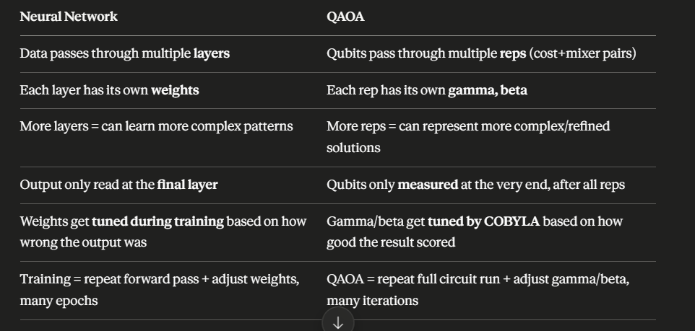

The QAOA circuit repeats the same fixed cost+mixer structure across reps (unlike neural network layers, which can each learn different transformations). COBYLA doesn't use backpropagation/gradients — it adjusts gamma and beta through trial-and-error style search, not gradient-based updates. (proba , deter)

A rotation gate is just a quantum gate that changes the direction (angle) of a qubit's state. By changing that angle, it changes the probabilities of measuring 0 or 1. In variational algorithms like VQE and QAOA, the classical optimizer repeatedly adjusts these rotation angles to find the quantum state with the lowest energy (or lowest cost).

VQE:
(Variational Quantum Eigensolver) is a hybrid quantum-classical algorithm that tries to find the lowest-energy state of a Hamiltonian.
Since optimization problems can be converted into a Hamiltonian, VQE can also solve optimization problems.

Unlike QAOA, VQE does not have Cost and Mixer layers.
Instead, it builds a flexible quantum circuit called an Ansatz.
The circuit contains rotation gates
Rotation gates are thing the we tune its angle and VQE try it to learn it
So each qubit start in quantum state and this rotation gate change its state we can think of it as arrows we try to change angle of this arrow like making it up or slightly left or slightly right s
This rotation gates start with random numbers at first they are just gusses then we can run this circuit and then after running we can measure its energy so classic optimizer takes this and try to tune this angles and run again repeats this steps until he found the lowest energy

AOA
- Fixed circuit architecture (Cost → Mixer → Cost → Mixer).
- The cost layer is constructed directly from the Ising Hamiltonian, which comes from the QUBO.
- QAOA creates a rotation gate for the variable qubit.
- The coefficients in the objective function, together with γ (gamma), determine the strength of the cost-layer rotations. ( rotation angle for rotation gate )
- The mixer layer is fixed and uses β (beta) to control exploration.
- COBYLA optimizes only γ and β.
VQE
- Flexible circuit architecture (called the ansatz). The user chooses which gates and how many layers to use.
- The rotation gates are part of the ansatz and are not derived from the cost function.
- The Hamiltonian is not used to build the circuit. Instead, it measures the energy of the quantum state produced by the circuit.
- COBYLA (or another classical optimizer) adjusts the ansatz parameters (θ₁, θ₂, …) to minimize the measured energy.

QAOA: The Hamiltonian builds the cost layer.
VQE: The Hamiltonian evaluates the circuit you designed.

